UNITED STATES

SECURITIES AND EXCHANGE COMMISSION
Washington, D.C. 20549

SCHEDULE 14A

(Rule 14a-101)

INFORMATION REQUIRED IN PROXY STATEMENT

SCHEDULE 14A INFORMATION

Proxy Statement Pursuant to Section 14(a) of the

Securities Exchange Act of 1934

Filed by the Registrant ☒

Filed by a Party other than the Registrant ☐

Check the appropriate box:

- Preliminary Proxy Statement

- Confidential, for Use of the Commission Only (as permitted by Rule 14a-6(e)(2))

- Definitive Proxy Statement

- Definitive Additional Materials

- Soliciting Material Pursuant to Rule 14a-12

FS INVESTMENT CORPORATION

(Name of Registrant as Specified In Its Charter)

(Name of Person(s) Filing Proxy Statement, if Other Than the Registrant)

Payment of Filing Fee (Check the appropriate box):

- No fee required.

- Fee computed on table below per Exchange Act Rules 14a-6(i)(4) and 0-11.

  - Title of each class of securities to which transaction applies:

  - Aggregate number of securities to which transaction applies:

  - Per unit price or other underlying value of transaction computed pursuant to Exchange Act Rule 0-11 (set forth the amount on which the filing fee is calculated and state how it was determined):

  - Proposed maximum aggregate value of transaction:

  - Total fee paid:

- Fee paid previously with preliminary materials:

- Check box if any part of the fee is offset as provided by Exchange Act Rule 0-11(a)(2) and identify the filing for which the offsetting fee was paid previously. Identify the previous filing by registration statement number, or the form or schedule and the date of its filing.

  - Amount Previously Paid:

  - Form, Schedule or Registration Statement No.:

  - Filing Party:

  - Date Filed:



Your clients are receiving this letter via email or mail over the next several days. We need your help. Please encourage your clients to respond to the proxy solicitation by voting in favor of each of the proposals described in the proxy materials in advance of this year’s annual stockholder meeting, which has been adjourned until August 6, 2013.
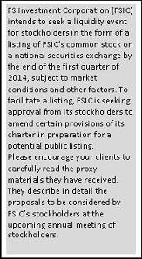

THREE WAYS TO VOTE:

WITHOUT A PROXY CARD

Call 877-807-6385 Monday to Friday,

9:00 a.m. to 9:00 p.m. EST to speak with a proxy specialist.

WITH A PROXY CARD:

Call 800-690-6903 with a touchtone phone to

vote using an automated system.

WWW.PROXYVOTE.COM

Your client should have his or her proxy card in hand when accessing the website. There are easy to follow directions to help your client complete the electronic voting instruction form.

VOTE PROCESSING

Have your client mark, sign and date his or her proxy card

and return it in the postage paid envelope provided.

More information and additional details will be shared regarding the FSIC listing in the coming months.

Thank you in advance for helping us with the proxy. It is an important first step towards listing.

GENERAL QUESTIONS?

Call 877-372-9880

PROXY QUESTIONS?

Call 877-807-6385

FOR BROKER DEALER USE ONLY. NOT FOR PUBLIC DISTRIBUTION. This is neither an offer to sell nor a solicitation of an offer to buy the securities described herein, which can only be made by a prospectus. This correspondence must be read in conjunction with FSIC’s periodic filings made with the Securities and Exchange Commission (the “SEC”) in order to fully understand all of the

implications and risks of investing in FSIC. Copies of these filings are available free of charge by contacting FSIC at Cira Centre,

2929 Arch Street, Suite 675, Philadelphia, PA 19104, by phone at 215-495-1150 or by visiting its website atwww.fsic.com. Neither the SEC, the Attorney General of the State of New York nor any state securities regulators have approved or disapproved of the securities described herein. Any representation to the contrary is a criminal offense.
If you prefer to no longer receive emails, please unsubscribe here.



Dear Fellow Stockholder:

We are pleased to inform you that we are preparing FS Investment Corporation (FSIC) for a liquidity event, which will likely be a listing of shares of our common stock on a national exchange. We believe a listing is the best avenue to maximize value for you, our stockholder. Market and other conditions permitting, we are currently planning to effect the FSIC listing by the end of the first quarter of 2014.

Before we can list, we must successfully complete this year’s annual stockholder meeting proxy process in advance of the date of the meeting, which has been adjourned until August 6, 2013. FSIC is seeking approval from its stockholders to amend certain provisions of its charter in preparation for a potential public listing. You have previously received the proxy materials, which describe the proposed amendments in detail. Please review them carefully.

Please respond to the proxy solicitation by voting in favor of each of the proposals described in the proxy materials by calling 1-877-807-6385. Failure to obtain the required votes will delay the listing process.

While our listing is likely several months away, we will continue to communicate with you on a regular basis. If you have any questions, please feel free to contact your financial advisor or visit our website at www.fsinvestmentcorp.com.

Thank you for your partnership as together we prepare FSIC for a potential public listing.

Sincerely,

Michael C. Forman

Chairman and Chief Executive Officer

FS Investment Corporation
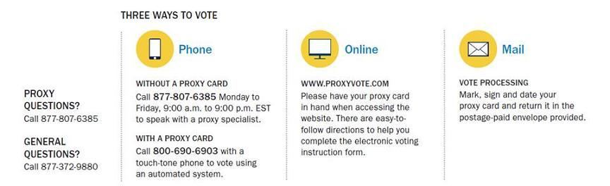

This is neither an offer to sell nor a solicitation of an offer to buy the securities described herein, which can only be made by a prospectus. This notice must be read in conjunction with FSIC’s periodic filings made with the Securities and Exchange Commission (the “SEC”) in order to fully understand all of the implications and risks of investing in FSIC. Copies of these filings are available free of charge by contacting FSIC at Cira Centre, 2929 Arch Street, Suite 675, Philadelphia, PA 19104, by phone at 215-495-1150 or by visiting its website at www.fsinvestmentcorp.com. Neither the SEC, the Attorney General of the State of New York nor any state securities regulators have approved or disapproved of the securities described herein. Any representation to the contrary is a criminal offense.

