UNITED STATES
SECURITIES AND EXCHANGE COMMISSION
Washington, D.C. 20549

SCHEDULE 14A
(Rule 14a-101)

INFORMATION REQUIRED IN PROXY STATEMENT
SCHEDULE 14A INFORMATION

Proxy Statement Pursuant to Section 14(a) of the
Securities Exchange Act of 1934

Filed by the Registrant ☒ Filed by a Party other than the Registrant ☐

Check the appropriate box:

☐ | Preliminary Proxy Statement
☐ | Confidential, for Use of the Commission Only (as permitted by Rule 14a-6(e)(2))
☐ | Definitive Proxy Statement
☒ | Definitive Additional Materials
☐ | Soliciting Material Pursuant to Rule 14a-12

FS KKR Capital Corp.
(Name of Registrant as Specified In Its Charter)

(Name of Person(s) Filing Proxy Statement, if other than the Registrant)

Payment of Filing Fee (Check the appropriate box):

☒ | No fee required.
☐ | Fee paid previously with preliminary materials.
☐ | Fee computed on table in exhibit required by Item 25(b) per Exchange Act Rules 14a-6(i)(1) and 0-11.

 | 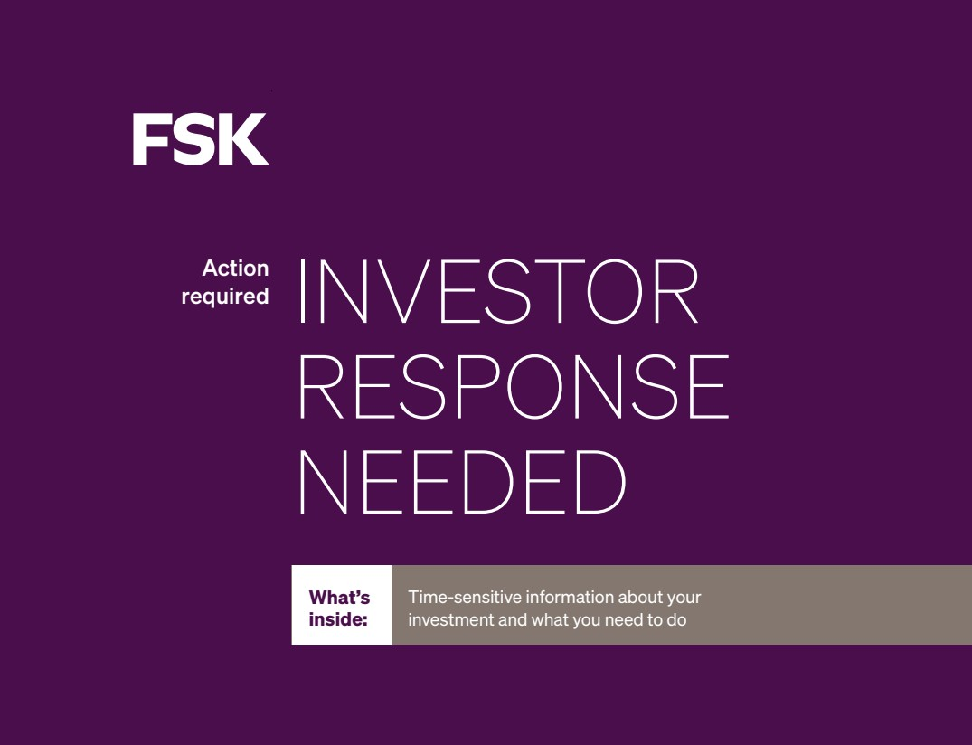 | INVESTOR RESPONSE NEEDED Action required What’s inside: Time-sensitive information about your investment and what you need to do
 | 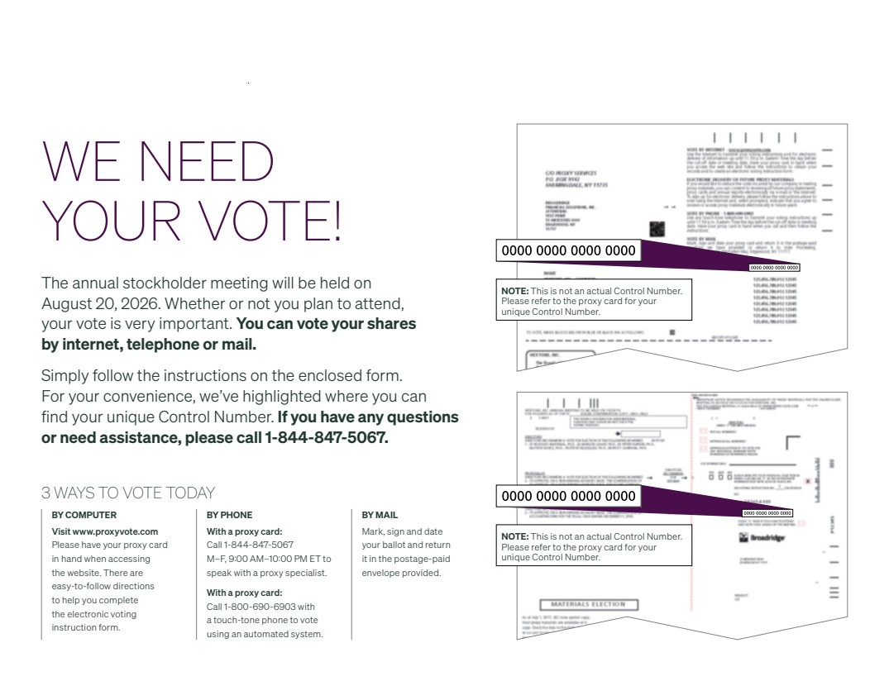 | WE NEED YOUR VOTE! The annual stockholder meeting will be held on August 20, 2026. Whether or not you plan to attend, your vote is very important. You can vote your shares by internet, telephone or mail. Simply follow the instructions on the enclosed form. For your convenience, we’ve highlighted where you can find your unique Control Number. If you have any questions or need assistance, please call 1-844-847-5067. NOTE: This is not an actual Control Number. Please refer to the proxy card for your unique Control Number. NOTE: This is not an actual Control Number. Please refer to the proxy card for your unique Control Number. 3 WAYS TO VOTE TODAY BY COMPUTER Visit www.proxyvote.com Please have your proxy card in hand when accessing the website. There are easy-to-follow directions to help you complete the electronic voting instruction form. BY PHONE With a proxy card: Call 1-844-847-50 M–F, 9:00 AM–10:00 PM ET to speak with a proxy specialist. With a proxy card: Call 1-800-690-6903 wi a touch-tone phone to vote using an automated system. BY MAIL Mark, sign and date your ballot and return it in the postage-paid envelope provided.
 |  | URGENT PROXY MATERIALS What’s inside Ensure your voice is heard.
WE NEED YOUR VOTE! The annual stockholder meeting will be held on August 20, 2026. Whether or not you plan to attend, your vote is very important. You can vote your shares by internet, telephone or mail. Simply follow the instructions on the enclosed form. For your convenience, we’ve highlighted where you can find your unique Control Number. If you have any questions or need assistance, please call 1-844-847-5067. NOTE: This is not an actual Control Number. Please refer to the proxy card for your unique Control Number. NOTE: This is not an actual Control Number. Please refer to the proxy card for your unique Control Number. 3 WAYS TO VOTE TODAY BY COMPUTER Visit www.proxyvote.com Please have your proxy card in hand when accessing the website. There are easy-to-follow directions to help you complete the electronic voting instruction form. BY PHONE With a proxy card: Call 1-844-847-50 M–F, 9:00 AM–10:00 PM ET to speak with a proxy specialist. With a proxy card: Call 1-800-690-6903 wi a touch-tone phone to vote using an automated system. BY MAIL Mark, sign and date your ballot and return it in the postage-paid envelope provided.
 | 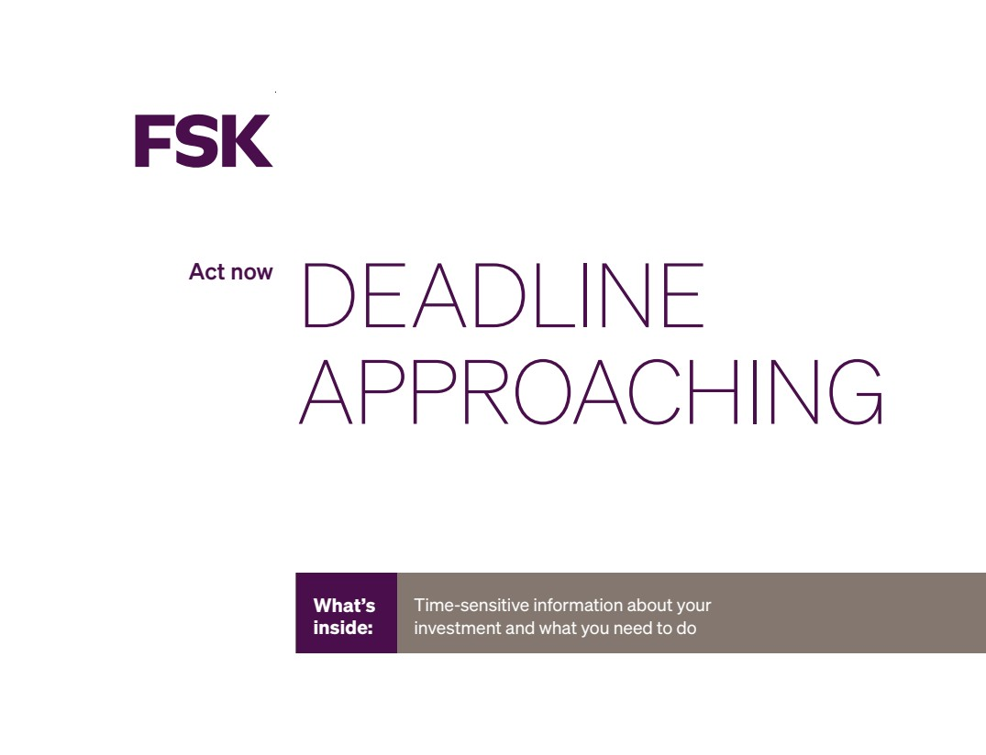 | DEADLINE APPROACHING Act now What’s inside: Time-sensitive information about your investment and what you need to do
WE NEED YOUR VOTE! The annual stockholder meeting will be held on August 20, 2026. Whether or not you plan to attend, your vote is very important. You can vote your shares by internet, telephone or mail. Simply follow the instructions on the enclosed form. For your convenience, we’ve highlighted where you can find your unique Control Number. If you have any questions or need assistance, please call 1-844-847-5067. NOTE: This is not an actual Control Number. Please refer to the proxy card for your unique Control Number. NOTE: This is not an actual Control Number. Please refer to the proxy card for your unique Control Number. 3 WAYS TO VOTE TODAY BY COMPUTER Visit www.proxyvote.com Please have your proxy card in hand when accessing the website. There are easy-to-follow directions to help you complete the electronic voting instruction form. BY PHONE With a proxy card: Call 1-844-847-50 M–F, 9:00 AM–10:00 PM ET to speak with a proxy specialist. With a proxy card: Call 1-800-690-6903 wi a touch-tone phone to vote using an automated system. BY MAIL Mark, sign and date your ballot and return it in the postage-paid envelope provided.

